**DLD tasks**

**Q1) (a)**

|  |  |  |  |  |  |  |
| --- | --- | --- | --- | --- | --- | --- |
| E | A | B | D0 | D1 | D2 | D3 |
| 1 | **X** | **X** | 1 | 1 | 1 | 1 |
| 0 | **0** | **0** | 0 | 1 | 1 | 1 |
| 0 | **0** | **1** | 1 | 0 | 1 | 1 |
| 0 | **1** | **0** | 1 | 1 | 0 | 1 |
| 0 | **1** | **1** | 1 | 1 | 1 | 0 |

**(b)**

**D0:**

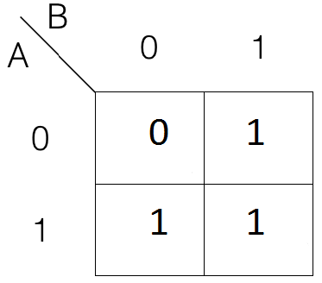

**D1:**

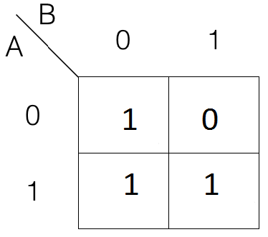

**D2:**

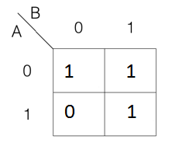

**D3:**

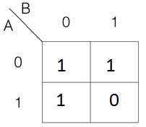

**SOP expressions:**

**D0 =** A+B

**D1 =** A+B’

**D2 =** A’+B

**D3 =** A’+B’

**POS expressions:**

**D0 =** AB

**D1 =** AB’

**D2 =** A’B

**D3 =** A’B’

**Q2)**

Circuit diagram:

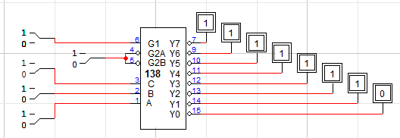

Truth table:

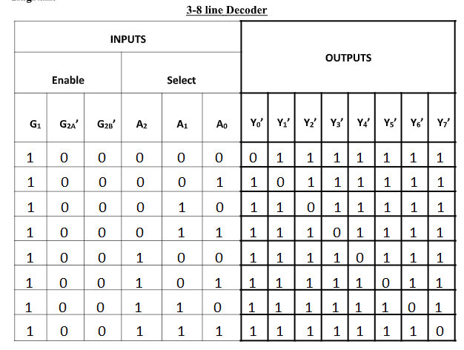

**Q3)**

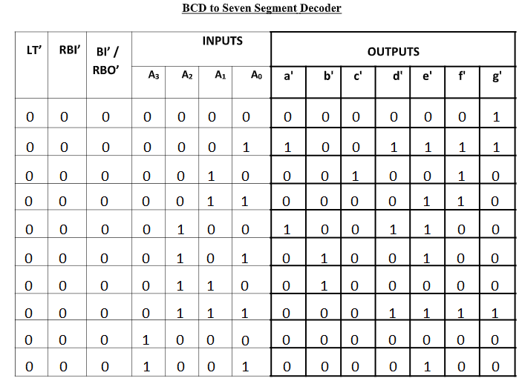

**Q4)**

